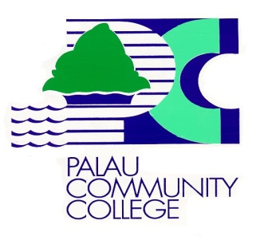
Institutional-Set Standards for Student Achievement (ISSA)
Recommendations Approved June 13, 2019
Implementation August 12, 2019

Beginning Academic Year 2019-2020, the following Institutional-Set Standards will continue to be implemented.

- At least 60% of registered students will complete enrolled courses (course completion) in any given semester.

- PCC retains at least 60% of registered students from term to term; fall to fall; and spring to spring until completion of degree/certificate programs.

- At least 70% of students will complete enrolled general education courses in any given semester.

- At least 10% of students enrolled will complete (graduate) in 2 – 2½ years.

- At least 20% of students enrolled will complete (graduate) in 3 - 3½ years.

- At least 20% of students who completed degree programs will transfer to 4-year colleges/universities.

- At least 50% of students who completed degree/certificate programs will enter the work force (job placement).

Institutional Set-Standards Documents

